2014 IEEE Workshop on Advanced Research and Technology in Industry Applications (WARTIA)

The Design of Teaching ManagementracleInformSecu

Audit Technology

XIA Sailian^{1,}

¹Hunan communication polytechnic, Changsha 410004,China ªXiasailian@yeah.net

Abstract—The information system procedures,auditisto asrecordwell as the sc

information system user activitysafetyin ofthethebehaviorsystem,of especia mechanism, it is not only ableperformancetoidetifymanagement,whoaccess tosuchthe system, and can be how to use_{This}the recording_{paperdiscusses}system, so_{the}as _{Ora}to provide the basisprocessfor ofthesecuriOfafter_{standard}yincients_{and}. _{Oracle database} oracle security audit technology is applied to the teaching
management information syste management information system, on the system of information

different modules selected th security is an important safeguard, provides an important

Finally according to the cha guarantee for multi-level management, made clear the role of

management information syste their duties, and especially for all kinds of personnel datab corresponding security audit p administrators and academic staff's liabilities accordingly t

monitor and record, it will effectively prevent illegal data
change and use, to implement the responsibility of the data
II.OVERVIEW OF ORACLE SECURI from problems has a key role, for the safety of the teaching
TECHNOLOGY management information system is very practical.
Safety audit is a new con
Keywords-Oracle security audit; B/S mode; Teaching | professional auditors in |  |  | acco
management; information system | and | regulations, | commissioned
I.INTRODUCTION | the | authorization | of the | auth
I.INTRODUCTION | activities or behavior |  |  | of s
With the development of | einviforonment,mation technologyindependentandinsp
teaching management in collegesthecorrespondiandungiversitiesvaluation. increasingly promote the isinformatizationthedatabaseconstopeructionation, teaching management informationtime, systemobject hasand becomeinformationthe basis of the survival and developmentDatabase-levelofficeauditandcanthe usesch the school has become the funcmost ions,importantimplementinfrationstructaurd Teaching management information[3-4]. systemRecord coveringtheauditallinforof the college educational administratusersession work,id,operationinvolves tt teaching plan, students admittedoperationto objecttheuniversity,name. stu achievement, teaching materialAuditmanagementsystemin andthe implemensoon many aspects, of which, suchdatabasetheauditstudendata'spretreatmgradui certificate information, andanalydisispositionoftheof datathe achievemining teaching materials and otherno malinfoperationrmation arebehaviorrelativecha sensitive [1]. At present, base,most useof theanomalyteachingdetectionmanagem information system are brightmonitoringtook andcertanalysisinsafetyof protection measures to protefunct ionsthe insecuorderity toof realizeteachi management information system,audit butanalysianysafetysystemprotectiocanbe system is not perfect, therespectivelysystemthe threisauditmay strategbeout of the illegal invasion, alsodata preprocessing,maybeinternalauditstaffanae database administrator deliberatelysystemis shownfalsifined,figuresecurity1. system arises at the historic moment [2].

At first, this paper studies the teaching management information system and the security of the database an points out that the teaching management information system is facing all kinds of security threats, the tra security means all kinds of examination and approval

978-1-4799-6989-0/14/$31.00©2014 IEEE 687

2014 IEEE Workshop on Advanced Research and Technology in Industry Applications (WARTIA)

 |  |  |  |  |  |  |  |  | _{link}III.THE TEACHING MANAGEMENT I
 |  |  |  |  |  |  |  | Database
 |  |  |  |  |  |  |  |  | SYSTEM FRAMEWORK BASED ON B/
 |  |  | System |  |  | login
 |  |  |  |  |  |  |  | Log out | B/S (Browser/Server) mode |  |  |  |  |  | is
 |  |  |  | strategy |  |  |  |  | multilayer structure of distr
 |  |  | Audit
 |  |  |  |  |  |  |  |  | (Browser) and Server (Server)
 |  |  |  |  |  |  |  | Association | mining pretreatment
 |  |  |  |  |  |  |  |  | Server, database Server, appl
 |  |  | Data | preprocessing
 |  |  |  |  |  |  |  | Preprocessing | sequencetherequestmining of the client to
 |  |  |  |  |  |  |  |  | the Web Server to the databas
 |  |  |  |  |  |  |  |  | ruleServerminingto query data in the f
 |  |  |  |  |  |  |  | Association
 |  |  | Data |  | preprocessing |  |  |  | the Browser |  | [5]. B/S |  | mode app
 |  |  |  |  |  |  |  | Sequential | pattern mining
 |  |  |  |  |  |  |  |  | thin client, the client usin
 |  |  |  |  |  |  |  |  | hardware | configuration requir
 |  |  |  |  |  |  |  |  | same time it has good expansib
 |  |  | Oracle audit analysis system
 |  |  |  |  |  |  |  |  | Interne. So B/s mode with its
 |  |  | Figure 1.Oracle audit analysis system model
 |  |  |  |  |  |  |  |  | high degree of information sh
Due to the ORACLE database can't achieve automatic
 |  |  |  |  |  |  |  |  | C/S mode.
recording data to modify the data before and after opera
 |  |  |  |  |  |  |  |  | The function of the teachin
can use the trigger, record the data code, can be reali
 |  |  |  |  |  |  |  |  | system overall design system
the audit data modification operations, as part of au
 |  |  |  |  |  |  |  |  | teaching | management, |  |  | school |  | m
system database level in the audit. As a result, the da
 |  |  |  |  |  |  |  |  | need of give attention to two
level audit by adopting ORACLE database system audit and
 |  |  |  |  |  |  |  |  | system operator, which guara
write the audit trigger the method of combining of mili
 |  |  |  |  |  |  |  |  | management |  | modernization. |  |  |  | Ou
database user operation, operation time, audit object
operation behavior. |  |  |  |  |  |  |  |  | management |  | information system
 |  |  |  |  |  |  |  |  | modules: school profile modul
 |  |  |  |  |  |  |  |  | module, | class |  | management |  | modu
 |  |  |  |  |  |  |  |  | teacher | management |  |  | module,
 |  |  |  |  |  |  |  |  | management |  | module, the teachi
 |  |  |  |  |  |  |  |  | module, | user |  | management |  | modu
 |  |  |  |  |  |  |  |  | diagram is shown in figure 2.
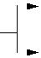
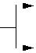
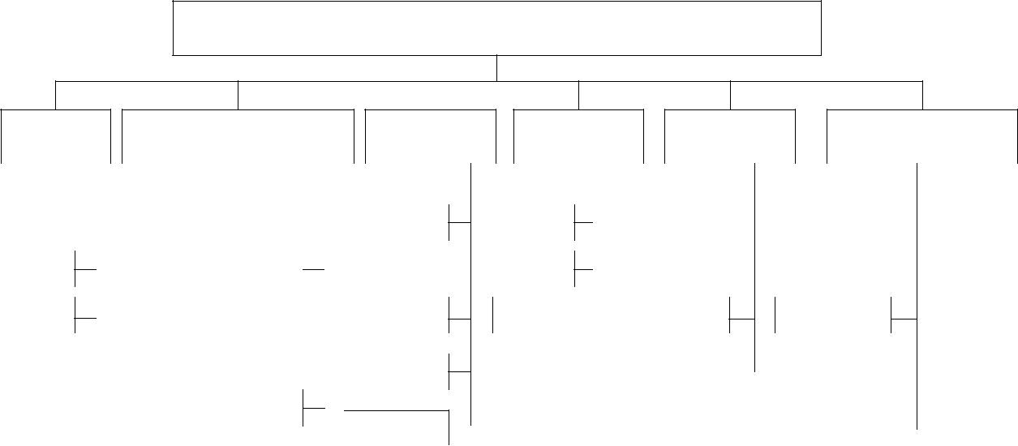

Educational administration management system

SchoolEducational adminiClasstrationExaminationTeachersStudent achievement profile managementmanagementmanagementmanagementmanagement
 | Entry |  |  |  |  | Calendar |  |  |  |  | Entry |  |  |  | Entry |  |  |  |  | Entry |  |  |  |  |  | Entry
 | Browse |  |  |  | Program |  |  |  |  |  | Query |  |  |  | Query |  |  |  |  | Query |  |  |  |  |  | Query
 |  | Print |  |  |  | Process |  |  | SchedulingHelp |  |  |  |  |  |  |  |  |  | StatisticalStatistical
 |  |  |  |  |  | Teaching
 |  |  |  |  |  | Teaching |  |  |  |  | Print |  |  |  |  |  |  |  |  | Help |  |  |  |  |  | Print
 |  |  |  |  |  | Statistical |  |  |  |  | query
 |  |  |  |  |  |  |  |  |  |  | Help |  |  |  |  |  |  |  |  |  |  |  |  |  |  | Help
 |  |  |  |  |  | Print
 |  |  |  |  |  | Figure 2. Teaching management information system
 |  |  |  |  |  |  |  |  |  |  |  |  |  |  |  | operating personnel on the et
IV.STRUCTURE DESIGN OF ORACLE SECURITY
 |  |  |  |  |  |  |  |  |  |  |  |  |  |  |  | only complicated, and there a
AUDIT TEACHING MANAGEMENT INFORMATION
 |  |  |  |  |  | SYSTEM |  |  |  |  |  |  |  |  |  | To monitor and record the us
 |  |  |  |  |  |  |  |  |  |  |  |  |  |  |  | operation of the data to the
Security |  |  |  |  |  |  |  |  |  |  |  |  |  |  |  | suspicious |  |  |  |  |  |  |  |  |  |  |  |  |  |  | to pr
 |  |  |  |  |  | audit is an important part ofoperation,themaagement
 |  |  |  |  |  |  |  |  |  |  |  |  |  |  |  | avoid important data leaks, i
information system security control, control of data f
basically |  |  |  |  |  |  |  |  |  |  |  |  |  |  |  | effective control of internal
 |  |  |  |  |  | based on the signature of the |  |  |  |  |  |  |  |  |  |  |  |  |  |  |  |  |  |  |  |  |  |  | paper and th
 |  |  |  |  |  |  |  |  |  |  |  |  |  |  |  | the |  |  | development |  |  |  |  |  |  |  |  |  | of security

688

2014 IEEE Workshop on Advanced Research and Technology in Industry Applications (WARTIA)

information system, as shownsystem,in thefiguredesign3. isTeachsuitablng management information systeminformationauditsubsystemsystem securitydesign isa the key to make sure mustthisauditmodel,vents,establishedimplementingthe software record of these events,auditdataand analysisstoreit,functionsinorde prevent the random access.anyAuditdatabasendrecordenginetheoperateddetails the system monitoring teachingand theseactivitiesrecords. Forcan succebeusedsf unsuccessful login attempt,operation,change ofunauthorizedsensitive data,user speaking, reading and writing,security,the administratorintegrity, andto deav important data, such as chansignificanceeeventrecord..

The audit system, respectively for the database

administrator, and office staff, the operation of the t ACKNOWLEDGEMENTS
secretary, teacher, student and so on identification
separation, auditing, record user behavior on the key
Hunan | province | education
activities in the teaching management information system
achievements, subject name:
not only can identify who a cess to the system, and can
school" | effect of higher voca
how to use the recording system, so as to provide the b
training | leading | practice tea
for the after process of approvalsecurity number:incidents,XJK014BGD025toeffect. prevent illegal data change and use. Auditing system c

provide statistics, analysis tools, statistics of va operating frequency; Provide statisticalREFERENCEanalysis too

analysis e in the audit |  |  |  |  |  |  |  |  | Scree
and monitors suspicious |  |  |  |  |  |  |  |  | [1] G. Ateniese, R. Burns R, onand R.
 |  |  |  |  |  |  |  |  | Information and System SecurityAudit.12. (TISScen
for auditors to provide |  |  |  |  |  |  |  |  | [2] Y. Zhu, H. Hu, G.J. Ahn:olJournal.85and
analysis function, provide |  |  |  |  |  |  |  |  | (2012) No.5, p. 1083
 |  |  |  |  |  |  |  |  | audit report.
 |  |  |  |  |  |  |  |  | [3] S. Wang, Z.: Cao,Scienceand inZnformation.ChinaChengSeri
 |  |  |  |  | Oracle |  | audit engine |  | Sciences, Vol.52 (2009) No.8, p. 1358
 |  |  |  |  |  |  |  |  | [4] G. Smith: teJournalAccountingofCorpora&(2007)Finance
 |  |  |  | Security |  | audit |  |  | No.4, p.43.
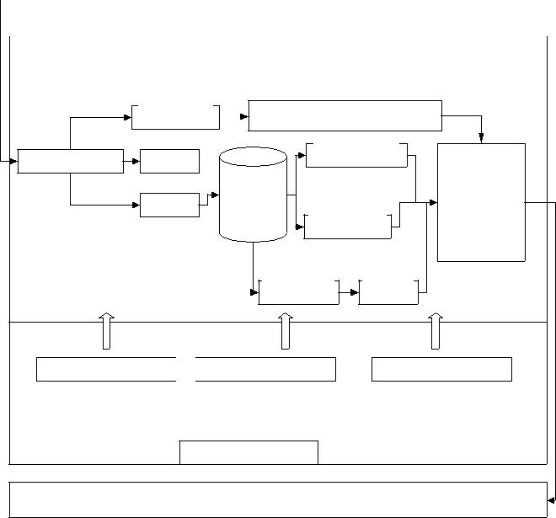

- E. Fernándezujillo,-Medina,and RJon. VillarTrSupportoe
Performancerformance monitoring Systems, Vol.42 (2006) No.3, p. 1270.
CommunicationLog | Session
 | Audit | Interface
Alarm database |  | Interface
 |  | display
 | Alarm | display

Audit | Analysis

Policy Auditing Database management

Windows Server 2003

Teaching management information system

Figure 3. Teaching management information system based on Oracl security audit

V.CONCLUSION

This paper takes the teaching management information system as the background, based on the analysis of th existing information system audit and on the basis of database security theory, puts forward and implements t scheme of database security audit, to a certain exten improved the security of the teaching management information system in our school. In this paper, accord to the characteristics of the Oracle database manageme

689

